Photo of a 2022 book burning in Tennessee

[They're Burning Books in Tennessee | Pith in the Wind | nashvillescene.com](https://www.nashvillescene.com/news/pithinthewind/theyre-burning-books-in-tennessee/article_1f8c631e-850f-11ec-bc9f-dbd44d7e14d7.html)

|  |  |
| --- | --- |
| operation intellectual freedom: the anarchy library | Benjamin Dieck, Diganta Rashed, & Sarah Rapp  IST659 #3702  Spring 2023 |

Operation Intellectual Freedom: The Anarchy Library

Contents

**Overview**: 2

1. Recommend 3 top-rated books that have been subject to a ban somewhere in the United States, based on a connection between the book’s content/theme and a user chosen topic. 3

2. Include in the recommendation more specific information on the book’s ban, including state. 3

3. Based on a book’s content/themes, provide a statistically accurate prediction of where in the United States it may be subject to a ban/challenge. 3

**Glossary**: 3

**Operation Intellectual Freedom (IF)**: A mission to help ensure equitable intellectual freedom by providing direct access to “troublesome” texts. 3

**Anarchy Library**: A curated collection of books that have been challenged or banned. (Future goal to include books that have the potential to be challenged or banned.) 3

**Challenged**: A book whose existence in a given collection is contested due to perceived content. 3

**Banned**: A challenged book that has been either forbidden to be taught to or read by certain people or has been removed from public access (most likely in a library) solely due to perceived content. 3

**Stakeholders**: 3

**Business Rules:** 4

**Conceptual Model*:** 4

**Normalized Logical Model*+:** 5

**Data Q&A:** 5

**Procedures with examples:** 7

**Summary:** 12

**Conclusion:** 12

**Reflection:** 13

**Log** 14

# **Overview**:

Controversial book topics and subsequent book bans are not new and may seem like antiquated concepts. Interestingly, as of late, the number of challenges and bans (and related legislation) is only increasing - according to PEN America they’ve recorded more than 4,000 instances of banned books from July 2021 to April 2023[1]. With a large number of these books about people of color/race, LGBTQIA+ content, and other concerns of marginalized people (like mental health awareness and coping), banishment means that the people who need these books are not able to easily get them - and are even having their intellectual freedom infringed on. The affected are largely youth that look to books to find content they can relate to or that helps them better understand/be exposed to the world around them. Operation Intellectual Freedom and the Anarchy Library look to close some of those gaps, provide education and awareness on where and when these events are happening, and to give a way to predict where a book may be challenged/banned. The database provides comprehensive knowledge and metrics on the key information that results in bans, frequentist data that provides a perspective on what elements contribute the most to bans, and what titles follow the trend of frequency. Using that information, a comprehensive review of the procedures and the general trends of the books and their status can be observed and analyzed to draw conclusions and understand trends regarding book bans, why they happen, and what are likely factors to cause them to take place.

**Goals**:

While we acknowledge Operation IF has untapped potential, including possible future enhancements, for the purpose of this project we aim to accomplish five primary goals:

## Recommend 3 top-rated books that have been subject to a ban somewhere in the United States, based on a connection between the book’s content/theme and a user chosen topic.

## Include in the recommendation more specific information on the book’s ban, including state.

## Based on a book’s content/themes, provide a statistically accurate prediction of where in the United States it may be subject to a ban/challenge.

1. Provide a random recommendation of a banned book for users that cannot decide what to read.
2. Provide users with descriptive statistics on the topic of banned books, challenges, etc. of the information within the database.

# **Glossary**:

## **Operation Intellectual Freedom (IF)**: A mission to help ensure equitable intellectual freedom by providing direct access to “troublesome” texts.

## **Anarchy Library**: A curated collection of books that have been challenged or banned. (Future goal to include books that have the potential to be challenged or banned.)

## **Challenged**: A book whose existence in a given collection is contested due to perceived content.

## **Banned**: A challenged book that has been either forbidden to be taught to or read by certain people or has been removed from public access (most likely in a library) solely due to perceived content.

# **Stakeholders**:

* The general public
* Librarians and library affiliates
* Authors
* Readers (listeners, consumers)
* Students and scholars
* Educators of all kinds

# **Business Rules:**

1. A registered user utilizing the banned app registers one account via email and cannot use the same email to register a second account.
2. A single book can have multiple authors.
3. A single author, identified in the authors table, cannot be entered into the authors table more than once.
4. A challenge ID cannot be used more than once, without referring to the same challenge.
5. A book ID cannot be used more than once referring to the same book.
6. A reason for a challenge can be used more than once, if it is referring to a different book as identified by its primary key.

# **Conceptual Model*:**

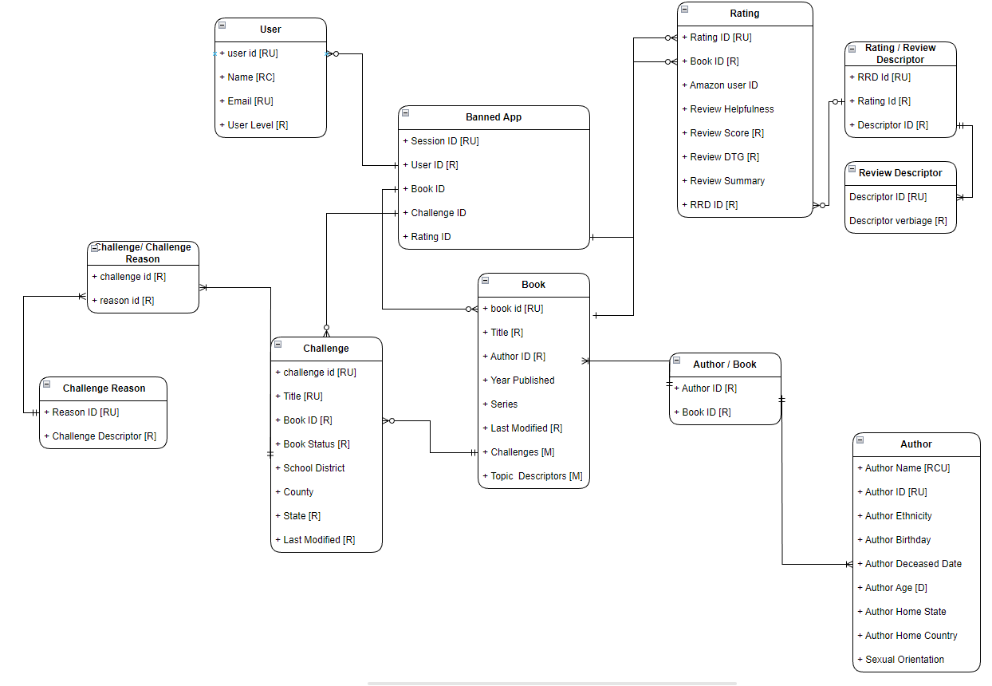

*zoom in for clarity

# **Normalized Logical Model*+:**

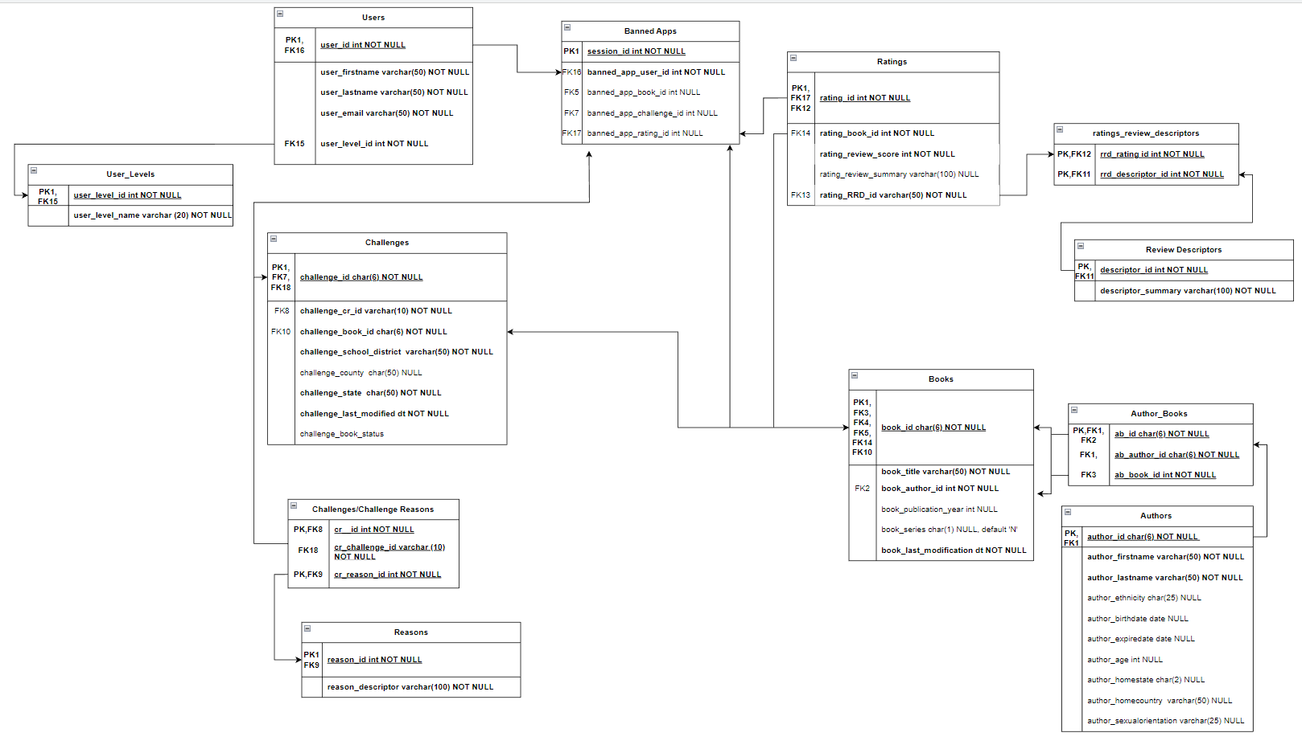

*Zoom in for clarity

+By design, our logical model is inherently 3rd normal form. Keys are resolved.

# **Data Q&A:**

**What are the most frequently banned keywords?**

This was calculated utilizing the procedure p_freq_words under the times_reason_challenged variable. We can see that the most banned reasons, across the database, are sexual topics, and strong / questionable language. These definitively are the most criticized with 85 and 83 reasons respectively. Violence is in the next tier with 49 challenges based on violent content. Explicit content, ‘obscene’ content, offensive content, age appropriateness, and sexually explicit material are all sitting between 35-39. It is interesting that obscene / offensive are both in this tranche as those are decidedly relative outlooks. In relation drug use, profanity, and child pornography were challenged less than 10 times. As was nudity.

**What are the most frequently banned books within the database?**

The most banned books, undoubtedly, are *Crank* and *All American Boys* with 150 challenges and 136 challenges respectively. Then *Flamer* at 60, and *My Sister’s Keeper* with 50. These are essentially two subject matters. Drugs, and topics within the Gay community. This is captured in the p_count_book_challenge procedure.

**What are the most hostile school districts?**

Utilizing the p_hostile_dist procedure, we can see that tied in first are Indian River County Schools of Florida, and Eanes School District of Texas at 14 unique challenges a piece.

These districts round out our top ten:

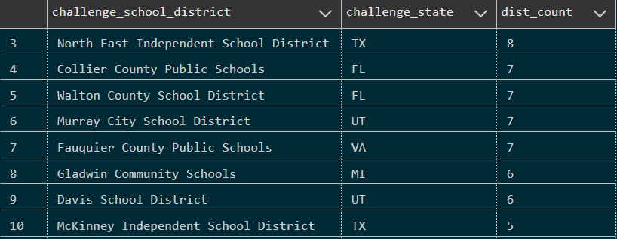

**What are the most hostile states?**

The two most hostile states, that issue the most challenges registered in the DB, by a landslide are Texas and Florida with 3 times as many challenges as the number three entrant sitting in the high fifties. The next category are Pennsylvania, Utah, and Virginia at around 14 challenges +/-2, Montana, Oklahoma, North Carolina, Tennessee, and Michigan are coming up next with between 5-10 challenges per state.

**What states / school districts challenge a given subject the most?**

This has numerous possibilities because of the amount of data that we have captured. However, for example, we can query where LGBT issues are challenged the most. The top ten list lies primarily in Texas. From the aforementioned outputs, we can observe that the most challenged school district is North East Independent School District, with Walton County, Granbury Independent, Katy, and Fauquier County coming in at a joint second for the most challenged. So, when ascertaining the total number of challenges, it is rather particular in terms of frequency. A better metric for analysis would be to understand and observe the frequency of threats based on the descriptive category to better understand the most threatening school district.

When looking at the districts, we can see that Texas was the most hostile and noteworthy state when it comes to the population of bans, with Florida and Pennsylvania following at 2nd and 3rd respectively.

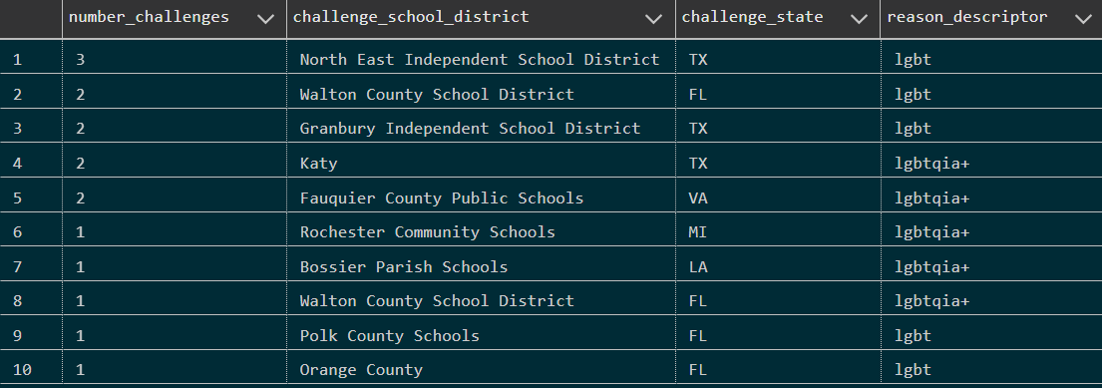

# **Procedures with examples:**

1. **Create a new user:**



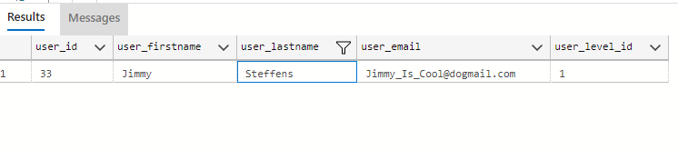

1. **Attempt to create duplicate user:**

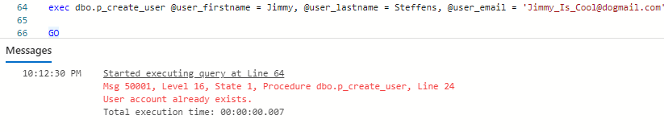

1. **Anarchy library (give me a random banned book to read):**

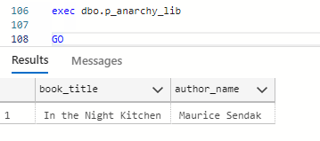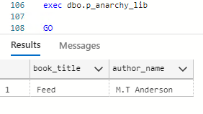

1. **Describe a book and find out where it could be banned:**

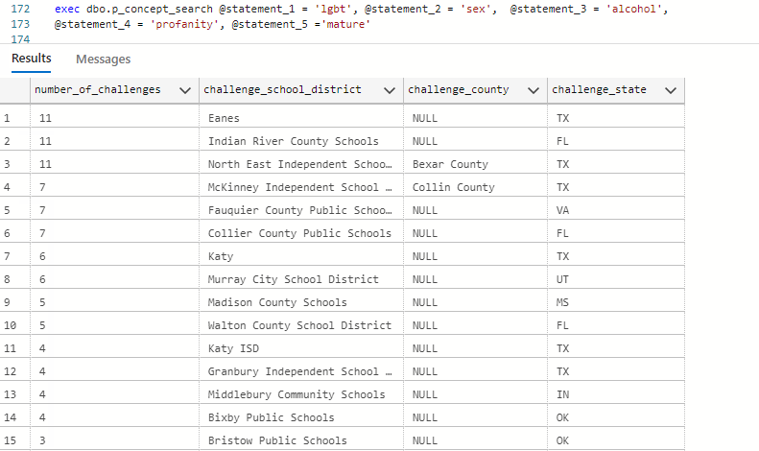

1. **Recommend top 3 books based on user input (and tell me where it was banned):**

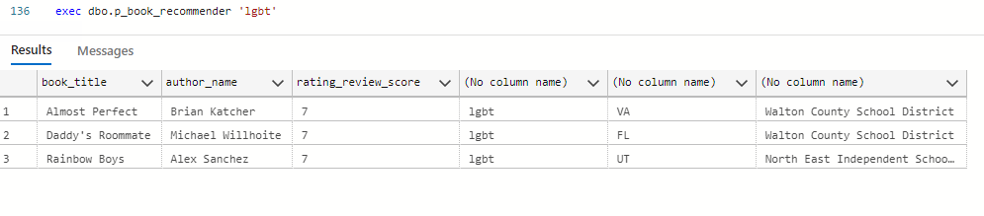

1. **Calculate the age of an author of a book based on present day given their provided date of birth:   
   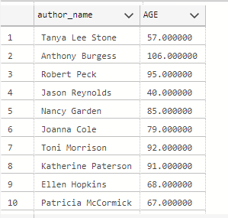**
2. **Identify the number of challenges obtained per school district in each state, to locate the most hostile school district for literature:**
3. **Identify the number of challenges obtained per state, to locate the most hostile state for literature:  
   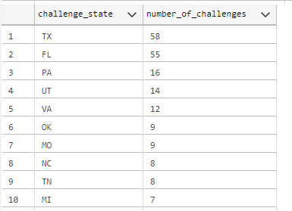**
4. **Identify the most frequently banned keywords:  
   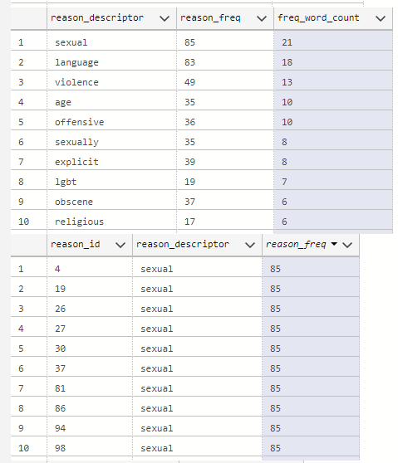**
5. **Identify the most frequently banned books based on banned keywords:   
   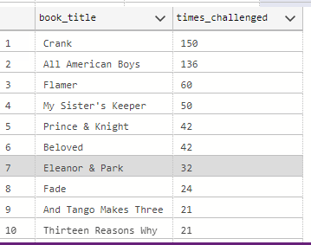**

# **Summary:**

Operation IF : The Anarchy Library creates a relational database that connects books to the challenges imposed on them, as well as connecting relational data that is connected with each book entry. We were able to categorize and generate outputs that displayed information regarding reasons for why a book was banned, how frequently a region bans books by category, and the likelihood of a book being banned due to the frequency of a category being banned. We were also able to generate additional, descriptive data about the books such as information about the authors, book titles, and generators to create randomized book recommendations along with targeted recommendations per user, and additional research metrics usable for other bibliophiles.

We seek to provide resources to lovers of books, authors, and researchers. The topic of banned books is ever present in society, and by and large it is encompassing more titles. The creation and application of this database stands to explain the breadth of the problem to anyone that wishes access to the information.

# **Conclusion:**

The created database and queries were successfully able to create an interface to filter and store information regarding the books and their attributes and create an output system where users can generate data regarding the different categorical outputs regarding why a book was banned, where it was banned, and frequency related to books being banned. Firstly, unique users were created with distinctions between each user so that users cannot be duplicated. Descriptive information regarding the book and its authors were displayed through the outputs, such as the title and category of a book and where it was banned, as well as the name and age of the authors.

In terms of business-relevant output, we were able to observe factors for why books were banned. Based on our outputs these were largely centered around sexual content, inappropriate language, and depictions of violence. We were also able to recognize Texas, Florida and Pennsylvania as the top 3 ranked states for banning books. *Crank*, *All American Boys* and *Flamer* were recognized as the top 3 most frequently banned books, with the top 10 most frequently banned books represented on graphics above. When it came to user preferences and input, we were able to generate the top 3 most recommended books based on user input, which would generate the top 3 most banned books given a category. In our demonstration, we selected the category “lgbt”, and the top 3 banned books based on the category were *Almost Perfect*, *Daddy’s Roommate*, and *Rainbow Boys* respectively. Additionally, we were able to implement a randomizer that would generate a recommendation for a banned book to read upon user input.

The functionality of the application can be largely expanded, both in terms of accessible data in its vastness and depth. It also requires functionality in terms of the user interface. A clear user interface can further streamline and optimize how well information can be output and presented. An increase in the data can not only more clearly answer present questions about literature banning trends, but also further provide additional insight into why books are banned and how to predict what may or may not be banned next.

We would really like to be able to share our research with the source materials for this project because the end goal of this is to share information, not horde it.

# **Reflection:**

One of the most interesting parts of this project was how many questions it had the potential to answer, and how many ideas there were to expand upon the core concept. The sheer fact is, we don’t have enough time to flesh it out.

The ability to tie a book challenge, to a reason it was challenged, reviews, ratings, or a synopsis of the book implies actually being able to judge whether a book is being challenged on its content. Or if only by the idea behind its content. It is a potential measure of whether the county / district that is attempting to ban the book knows anything more about the book than the core concept or what is printed on the cover. We could spot geographic trends of bigotry and intolerance with this information. Or whether the author is, perhaps, more important than the book. It is a potential measure of blind prejudice that I would hope might be useful as a societal spotlight.

One of the key ironies here is that we are using inferential reasoning from aggregate data sourcing to draw leading conclusions about places we don’t live, have never been to, probably don’t know a thing about; but we are drawing inferences that some places are more likely than others to ban a book from schools / public discussion because it might, for instance, discuss boys kissing. We are being highly prejudicial about those we are inferring to have strong prejudice based on data.

I feel like I would highly enjoy continuing to work on this project. Or if nothing else, discuss it with some of the people that we sourced our data from.

A quick add to the above sentiments – I was most surprised how this small kernel of an idea was transformed into, well maybe not a full-fledged flower, but an eager blossoming bud! Even in the short amount of time we had, this project became something with some real potential usefulness and when all is said and done, that is a good feeling. I do feel like this should be the second half of a two-semester course, but I enjoyed learning some of the concepts and this course helped me figure out what final direction to take in grad school overall.

# **Log**

**Meetings:**

5/1/23, 5/7/23, 5/11/23, 5/18/23, 5/25/23, 6/1/23, and 6/8/23. Most meetings were fully attended. Additional consistent communication through the Teams chat throughout the project.

**Database programming:**

Primary - Ben Dieck. Supporting - Diganta Rashed and Sarah Rapp.

**Team paper and PowerPoint:**

Mutual collaboration between all three members.

1. [Book bans soar in U.S. schools, largely in Republican-led states - Los Angeles Times (latimes.com)](https://www.latimes.com/world-nation/story/2023-04-22/book-bans-soaring-schools-new-laws-republican-states#:~:text=In%20a%20report%20published%20Thursday%20by%20PEN%20America%2C,28.5%25%20from%201%2C149%20cases%20in%20the%20previous%20semester.)